**PRINT-ON-DEMAND**

**Context Free Diagram**:

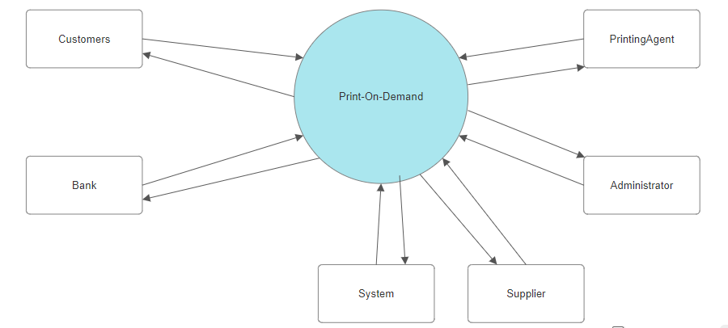

Here the system has six entities , 1.Customer

2.Printing Agent

3.Bank

4.System

5.Supplier

6.Admin

**UseCase Diagram**:

Customer needs to create an account first . For creating an account he/she must enter the details like username , address , creditCard details and all.

Customer will place the order , after which it gets checked by the system.

Checking includes activity like requesting approval of credit card from the bank.

Then only the order will get finalized.

Admin will monitor the stocks.

If there’s insufficient amount of stocks present , the supplier needs to supply the resources.

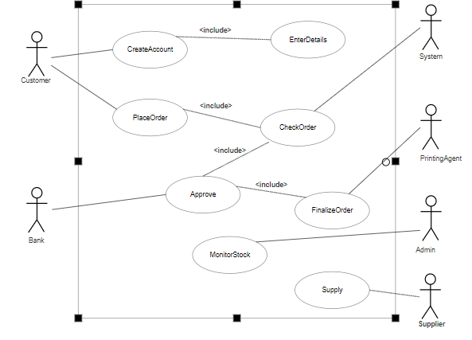

**Class Diagram**:

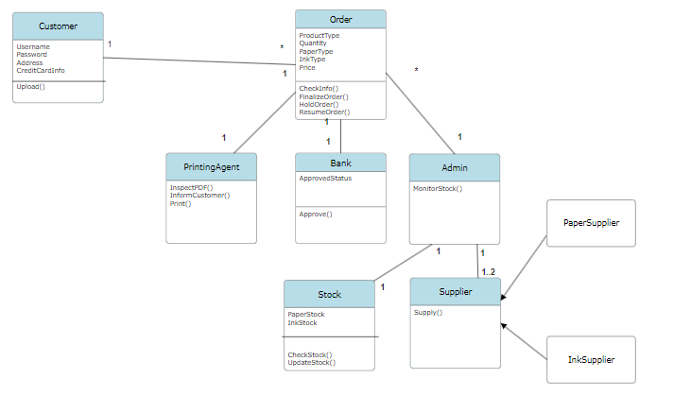

Each customer can place multiple orders.

And one order of printing stuffs should be print and delivered by one printing-agent.

As each customer can place order with only one credit card , that’s why the relationship between the order and bank class will be 1:1 association.

Admin can ask for supplies from paper supplier or ink supplier.

Stock class has attributes like PaperStock and InkStock. It can check the availability of the resources.

**Sequence Diagram**:

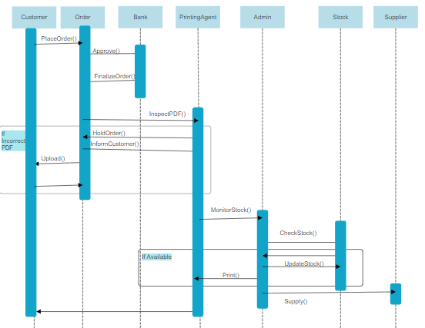

First customer will place the order.

Bank needs to approve the credit card , then only the order will be finalized.

Then the PDF will get inspected by the Printing agent , and if there’s any fault , the order will be hold until it gets the right data from customer.

After that Admin needs to monitor the stocks , and if there’s unavailability , supplier will supply , and the order will be delivered to customer.